Jhunguide Flores Created at: April 10,2025  
BSIT 3rd Year

**Application Development Part 2**  
  
Simple_Dialog.py  
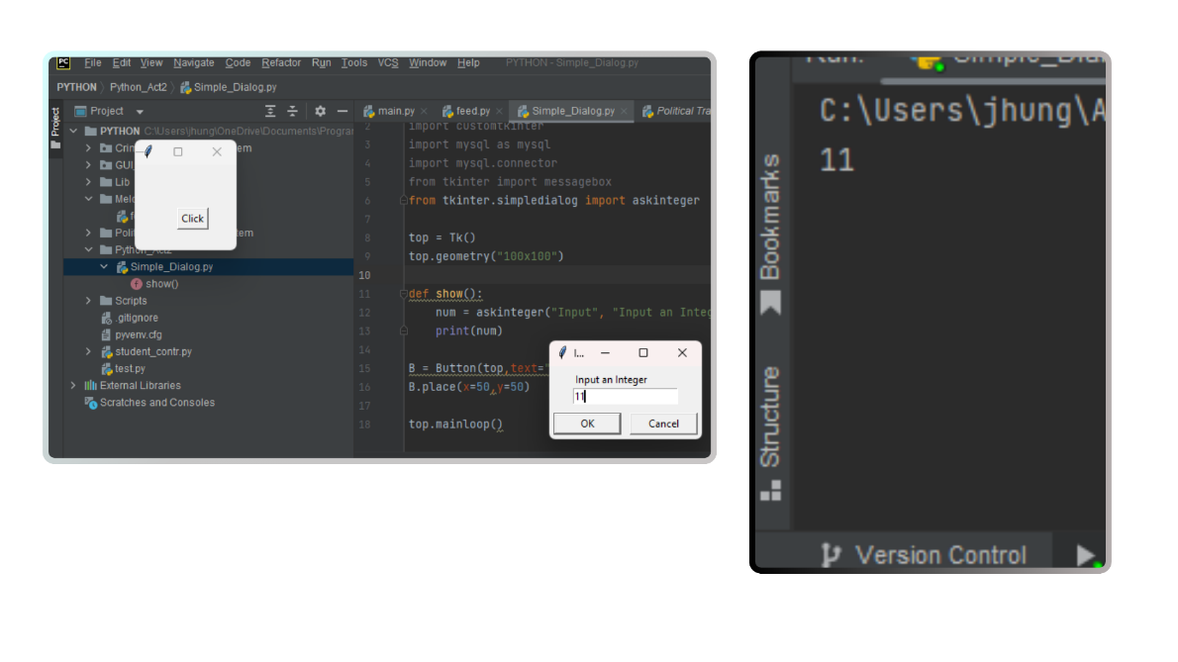  
Simple_Dialog_FloaT.py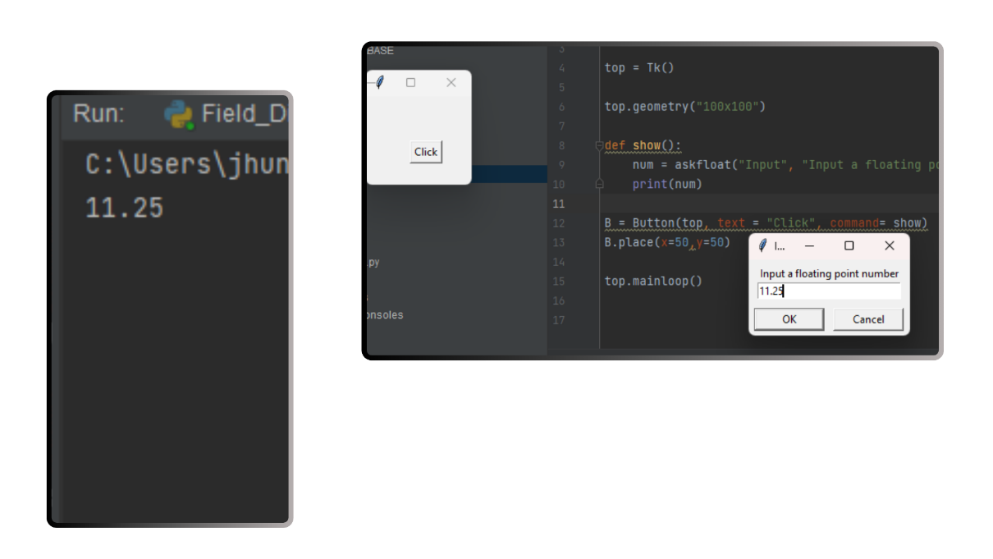  
File_dialog.PY  
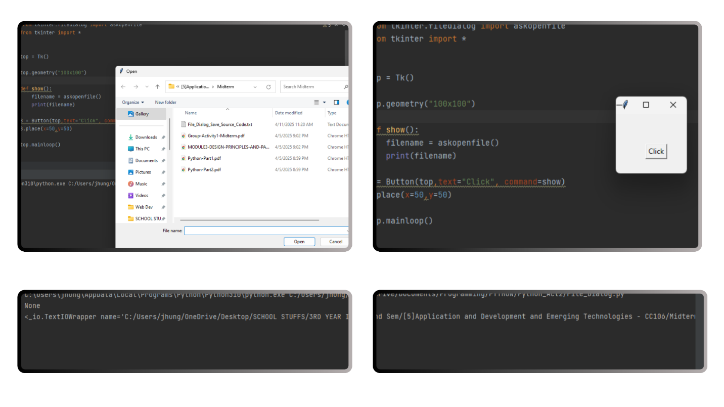  
  
File_DIALOG_SAVE.PY  
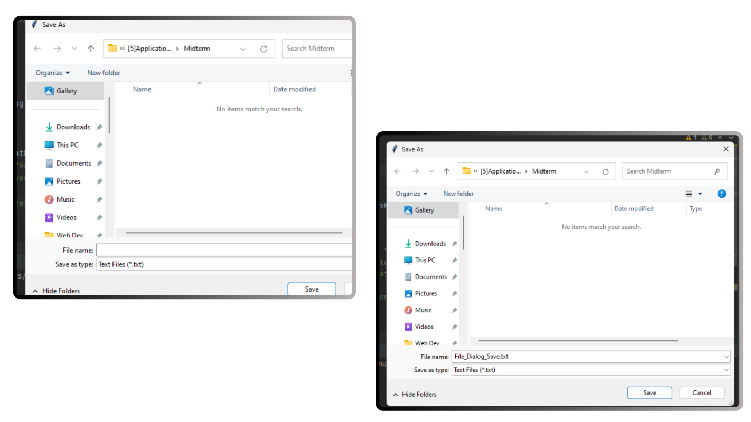combo_box.Py  
